**Data Description:**

17-folders, one per subject:

11-subfolders, one per activity:

3 - subfoldes , one per trial:

1-csv file and image data

**Layout diagram**

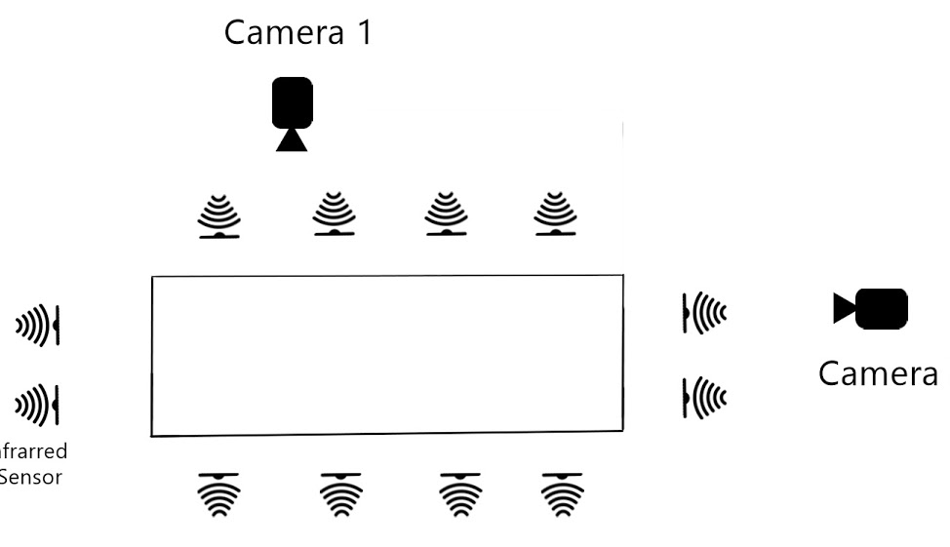

**Size of data:**Nearly 160000 rows and images of data

**Mapping** : mapping images with csv(sensor data) time stamp

**Predictive modelling using Convolutional neural networks and LSTM:**

We can use convolutional neural networks to represent the image at each time stamp in a much lower dimensional space e.g, (240*240*3) into 1*10

**CNN**(Convolutional neural networks)

In neural networks, Convolutional neural network is one of the main categories to do images recognition, **images classifications**,Objects detections, recognition faces .

**LSTM(**Long Short Term Memory networks**)**

recurrent neural networks have the form of a **chain of repeating modules** of neural network.

After representing each image in a lower dimensional we can pass that into LSTM along with the tabular data which contains the values from sensors, at each time stamp and we can run LSTM on multiple timesteps, which can essentially extract important correlations across each timestep from both image and tabular data.

At the end of all the timestamps we can tell the LSTM to learn from the actual labels in the training phase by measuring how much it is off from the actual label.

Computationally expensive (GPU on cloud)